**16-720 Computer Vision: Homework 3 (Fall 2022)**

**Augmented Reality with Planar Homographies**

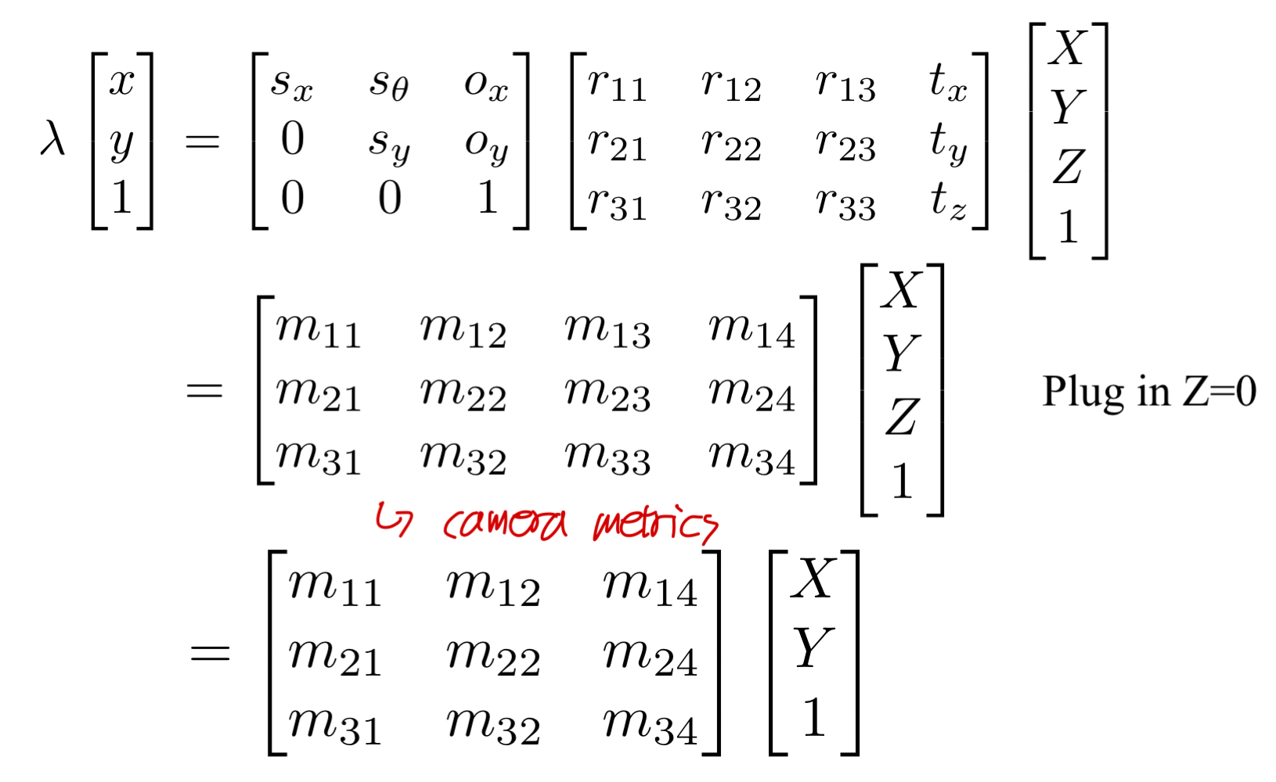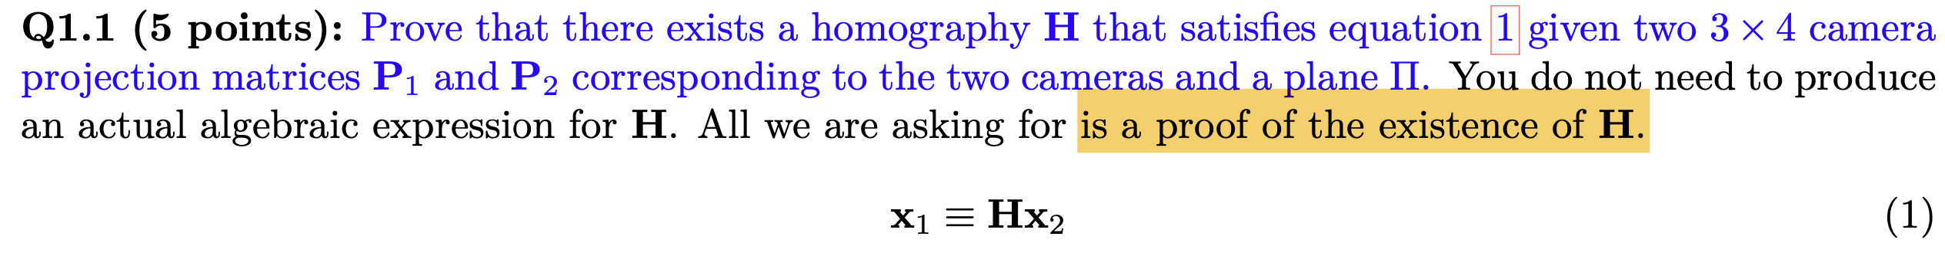Haejoon Lee

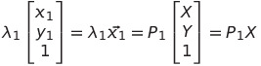, 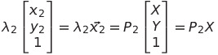



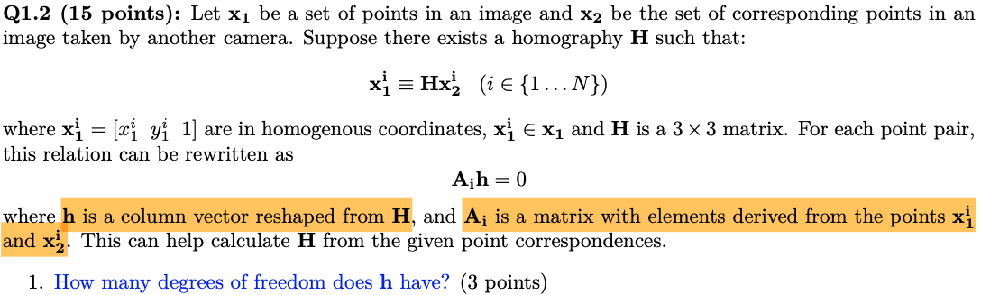Ans: 8

Ans: 4

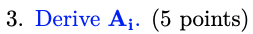

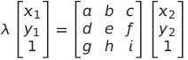

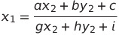, 

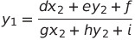, 

->

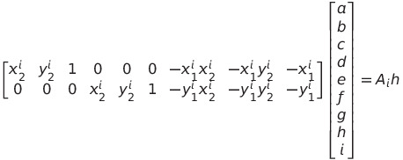

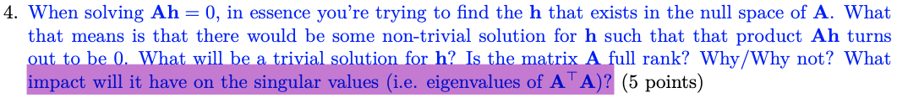The trivial solution for h will be h = 0

The matrix A will not be full rank if there are some non-trivial solutions thus Nullity(A) $≠$ 0

If the smallest singular values is 0, then the corresponding eigen vector is the solution for Ah = 0.

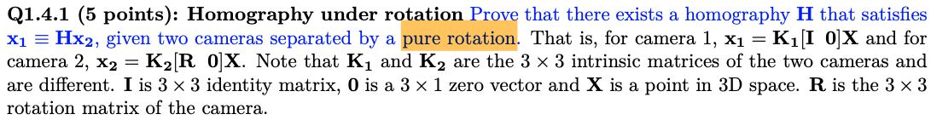There is no transition:

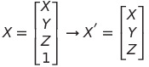

, 

->



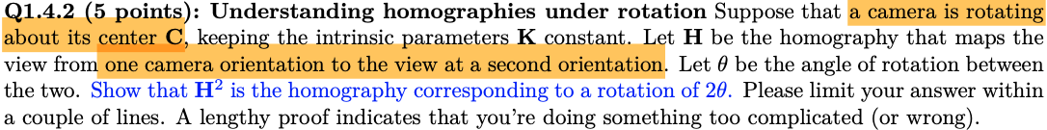





Ans: If the camera is heading exactly toward an edge of a plane, then it will appear as a line in a image and non-invertible.

Let’s express a line in 3D as below:



t is a variable and k, a, l, b, m, c are constants

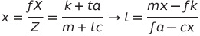.

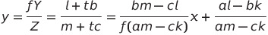

Thus, it’s line in the image.



Ans:

FAST detector detects key points by comparing pixel intensities. Therefore, it doesn’t need to compute gradient image, det(), or trace() like Harris corner detector so could be faster.

BRIEF only provide binary vector as output by comparing pixel values, the other filter banks generate the result with constant values from convolution. I think edge detection filters could be used as a descriptor.

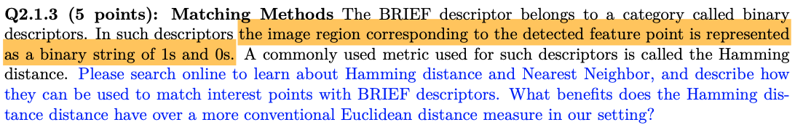By calculating Hamming distances between binary vectors of feature points in BRIEF descriptor, the nearest point is matched to one. Since the sequence of binary values in a vector is encoding which comparison result of two pixel points the value is indicating, Hamming distance was more appropriate than Euclidean.

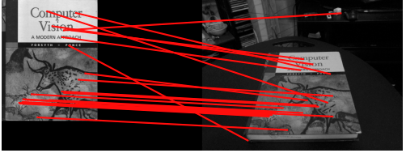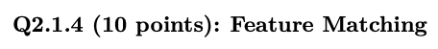

def matchPics(I1, I2, opts):

"""

Match features across images

Input

-----

I1, I2: Source images

opts: Command line args

Returns

-------

matches: List of indices of matched features across I1, I2 [p x 2]

locs1, locs2: Pixel coordinates of matches [N x 2]

"""

ratio = opts.ratio #'ratio for BRIEF feature descriptor'

sigma = opts.sigma #'threshold for corner detection using FAST feature detector'

# sigma=float(0.15)

# ratio=float(0.7)

# max_iters=int(500)

# inlier_tol=float(2.0)

# TODO: Convert Images to GrayScale

I1_gray = cv2.cvtColor(I1, cv2.COLOR_BGR2GRAY)

I2_gray = cv2.cvtColor(I2, cv2.COLOR_BGR2GRAY)

# TODO: Detect Features in Both Images

locs1 = corner_detection(I1_gray, sigma)

locs2 = corner_detection(I2_gray, sigma)

# TODO: Obtain descriptors for the computed feature locations

desc1, locs1 = computeBrief(I1_gray, locs1)

desc2, locs2 = computeBrief(I2_gray, locs2)

# TODO: Match features using the descriptors

matches = briefMatch(desc1, desc2, ratio)

return matches, locs1, locs2

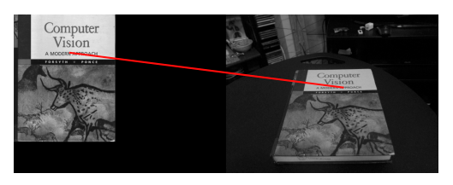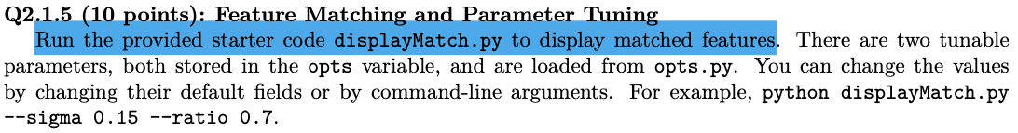

When I increased sigma value to 0.5, I got only one match. Because the sigma value is the threshold value for Fast detector, it will result in fewer detected points and match as it increased.

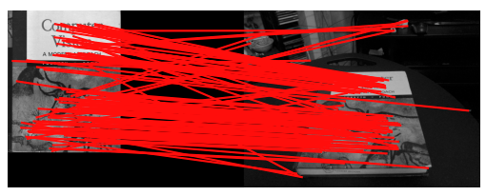

When I increased ratio to 0.9, I got much more matches. The value represent the maximum ratio of distances between first and second closest descriptor in the second set of descriptors. As increasing this threshold, more ambiguous matches between the two descriptor sets appeared.

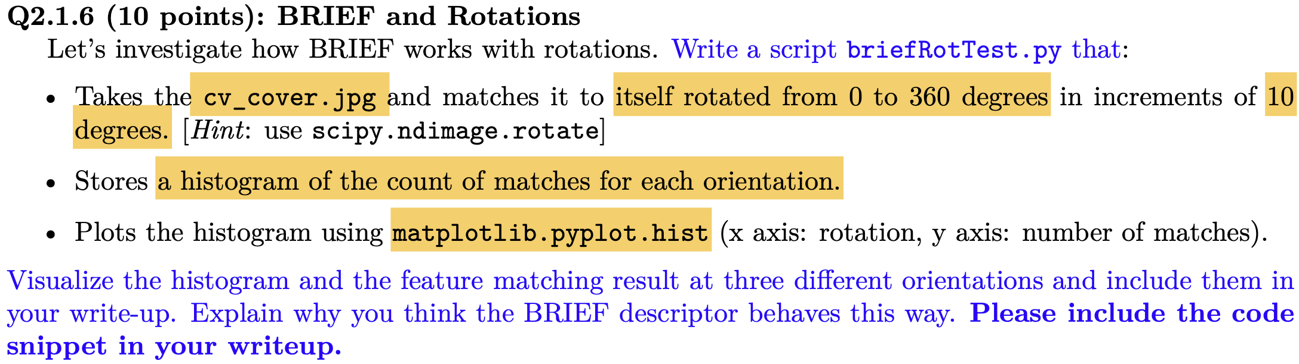

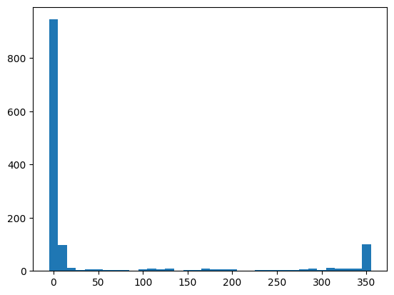

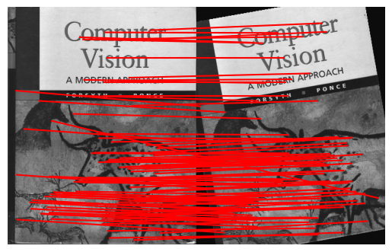

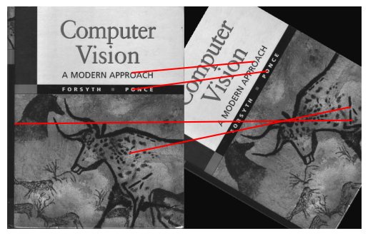

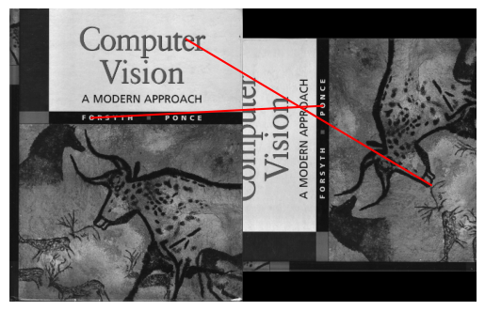

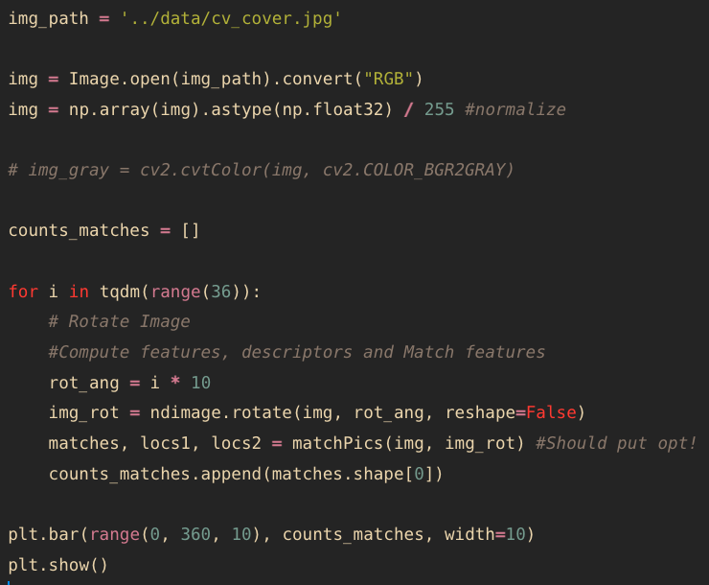

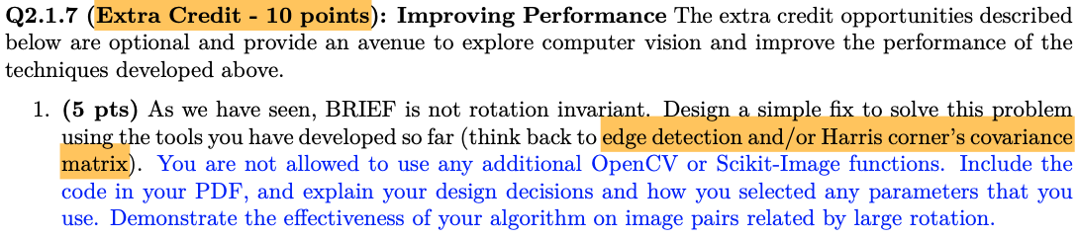 # Q2.1.4

def matchPics_modi(I1, I2, angle_rot, opts):

"""

Match features across images

Input

-----

I1, I2: Source images

opts: Command line args

Returns

-------

matches: List of indices of matched features across I1, I2 [p x 2]

locs1, locs2: Pixel coordinates of matches [N x 2]

"""

ratio = opts.ratio #'ratio for BRIEF feature descriptor'

# ratio = 0.7 #'ratio for BRIEF feature descriptor'

sigma = opts.sigma #'threshold for corner detection using FAST feature detector'

# TODO: Convert Images to GrayScale

I1_gray = cv2.cvtColor(I1, cv2.COLOR_BGR2GRAY)

I2_gray = cv2.cvtColor(I2, cv2.COLOR_BGR2GRAY)

I2_gray = ndimage.rotate(I2_gray, -angle_rot, reshape = False) # rotate I2 to be aligned with I1.

# TODO: Detect Features in Both Images

locs1 = corner_detection(I1_gray, sigma)

locs2 = corner_detection(I2_gray, sigma)

# TODO: Obtain descriptors for the computed feature locations

desc1, locs1 = computeBrief(I1_gray, locs1)

desc2, locs2 = computeBrief(I2_gray, locs2)

# TODO: Match features using the descriptors

matches = briefMatch(desc1, desc2, ratio)

R = np.array([[np.cos(angle_rot*(np.pi/180)), -np.sin(angle_rot*(np.pi/180))],

[np.sin(angle_rot*(np.pi/180)), np.cos(angle_rot*(np.pi/180))]])

#move the center coordinate of locs2 to (0, 0)

locs2[:,0] = locs2[:,0] - I2_gray.shape[0]/2

locs2[:,1] = locs2[:,1] - I2_gray.shape[1]/2

#rotate locs according to the original angle

locs2 = (R @ locs2.T).T

#relocate the center coordinate of locs2

locs2[:,0] = locs2[:,0] + I2_gray.shape[0]/2

locs2[:,1] = locs2[:,1] + I2_gray.shape[1]/2

# locs2 = R @ locs2.T

return matches, locs1, locs2

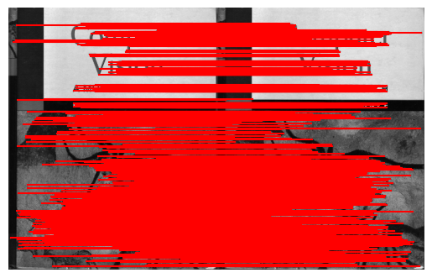

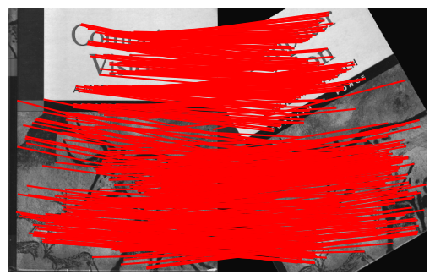

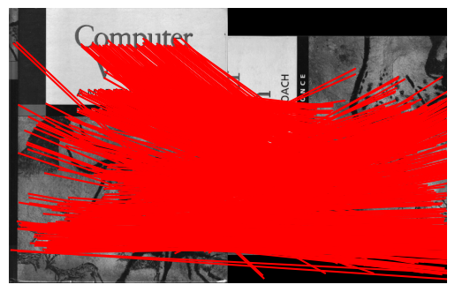

If we know the rotated angle, we can rotate the input image with the same angle by opposite direction and find matches. And then, rotate the coordinates of matches again. With this method, I could get rotate-invariante results as above.

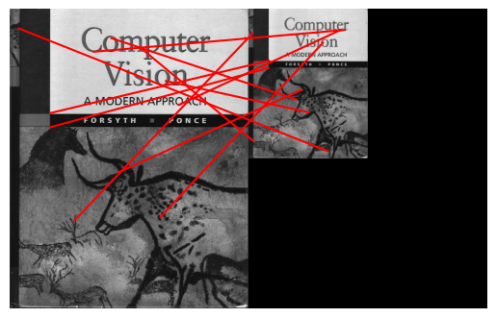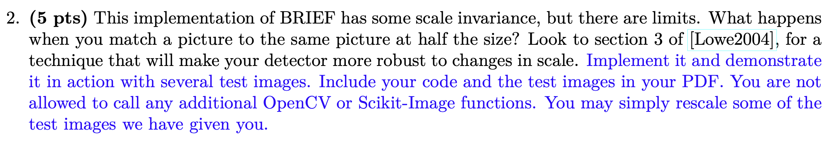

As shown above, the BRIEF descriptor showed poor result when I halved the width and height of the image. Following the section 3 of Lowe2004, I computed DOG and perform detection.

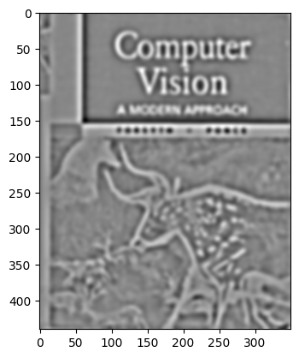

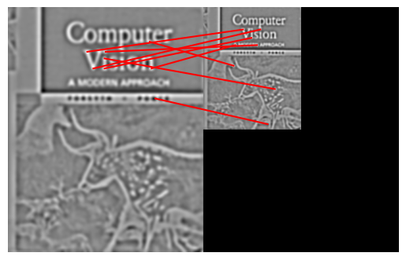

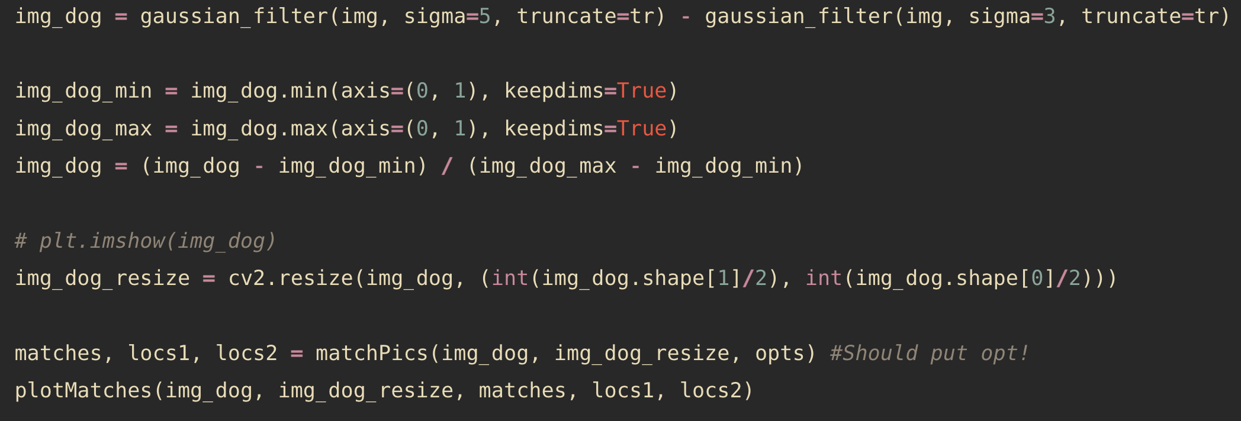

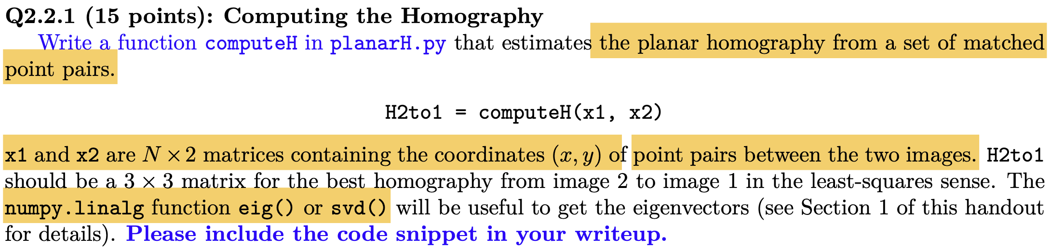

def computeH(x1, x2):

#Q2.2.1

#Compute the homography between two sets of points

indx_rand = np.random.randint(len(x1), size=4)

A = []

for i in indx_rand:

xcor2, ycor2 = x2[i]

xcor1, ycor1 = x1[i]

Ai = np.array([[xcor2, ycor2, 1, 0, 0, 0, -xcor1 * xcor2, -xcor1 * ycor2, -xcor1],

[0, 0, 0, xcor2, ycor2, 1, -ycor1 * xcor2, -ycor1 * ycor2, -ycor1]])

A.append(Ai)

A = np.vstack(A)

U, S, V = np.linalg.svd(A)

H2to1 = V.T[:, -1].reshape([3, 3])

return H2to1



def computeH_norm(x1, x2):

#Q2.2.2

#Compute the centroid of the points

mean1 = np.mean(x1, axis=0)

mean2 = np.mean(x2, axis=0)

#Shift the origin of the points to the centroid

x1 = x1 - mean1

x2 = x2 - mean2

#Normalize the points so that the largest distance from the origin is equal to sqrt(2)

max1 = np.max(np.linalg.norm(x1, axis=1))

max2 = np.max(np.linalg.norm(x2, axis=1))

if max1 == 0: #if max = 0 -> # of point in x is single and its value is 0

c1 = 1

else:

c1 = 1 / (max1 / 2 ** 0.5)

if max2 == 0:

c2 = 1

else:

c2 = 1 / (max2 / 2 ** 0.5)

x1 *= c1

x2 *= c2

#Similarity transform 1

T1 = np.array([[c1, 0, -c1 * mean1[0]], [0, c1, -c1 * mean1[1]], [0, 0, 1]])

#Similarity transform 2

T2 = np.array([[c2, 0, -c2 * mean2[0]], [0, c2, -c2 * mean2[1]], [0, 0, 1]])

#Compute homography

h = computeH(x1, x2)

#Denormalization

H2to1 = np.linalg.inv(T1).dot(h).dot(T2)

return H2to1



def computeH_ransac(locs1, locs2, opts):

#Q2.2.3

#Compute the best fitting homography given a list of matching points

max_iters = opts.max_iters # the number of iterations to run RANSAC for

inlier_tol = opts.inlier_tol # the tolerance value for considering a point to be an inlier

locs1_hc = np.hstack((locs1, np.ones((len(locs1), 1))))

locs2_hc = np.hstack((locs2, np.ones((len(locs2), 1))))

for i in range(0, max_iters):

H = computeH_norm(locs1, locs2)

locs2_warped = H @ locs2_hc.T

locs2_warped /= locs2_warped[2, :]

locs2_warped[2, :] = np.ones(locs2_warped.shape[1])

error_sub = locs1_hc.T - locs2_warped

error_squar = np.sum(error_sub ** 2, axis=0)

inlier_idx = (error_squar <= inlier_tol**2).astype(int)

if i == 0:

bestH2to1 = H

inliers_best = inlier_idx

if np.sum(inlier_idx) > np.sum(inliers_best):

bestH2to1 = H

inliers_best = inlier_idx

# print(inlier_idx)

return bestH2to1, inliers_best



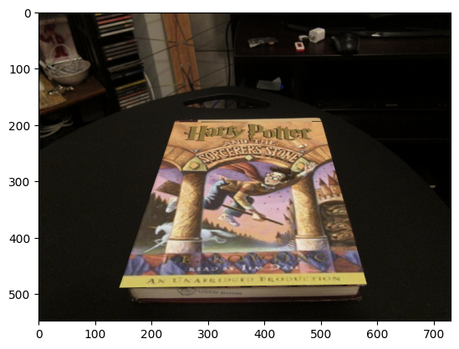

def warpImage(opts):

img_cv_covoer_path = '../data/cv_cover.jpg'

img_cv_cover = Image.open(img_cv_covoer_path).convert("RGB")

img_cv_cover = np.array(img_cv_cover).astype(np.float32) / 255 #normalize

img_cv_desk_path = '../data/cv_desk.png'

img_cv_desk = Image.open(img_cv_desk_path).convert("RGB")

img_cv_desk = np.array(img_cv_desk).astype(np.float32)/ 255 #normalize

img_hp_cover_path = '../data/hp_cover.jpg'

img_hp_cover = Image.open(img_hp_cover_path).convert("RGB")

img_hp_cover = np.array(img_hp_cover).astype(np.float32)/ 255 #normalize

# cv_cover: 440x350x3, hp_cover: 295x200x3

# resize hp_cover to be matched with cv_cover

h_cv_cover, w_cv_cover = img_cv_cover.shape[0], img_cv_cover.shape[1]

img_hp_cover_resized = cv2.resize(img_hp_cover, (w_cv_cover, h_cv_cover))

# rotated_image = ndimage.rotate(cv_desk, 40, reshape=False)

matches, locs1, locs2 = matchPics(img_cv_desk, img_cv_cover, opts)

locs1_matched = locs1[matches[:, 0]]

locs2_matched = locs2[matches[:, 1]]

bestH2to1, inliers = computeH_ransac(locs1_matched, locs2_matched, opts)

img_hp_warped = cv2.warpPerspective(img_hp_cover_resized.swapaxes(0, 1), bestH2to1, (img_cv_desk.shape[0], img_cv_desk.shape[1])).swapaxes(0, 1)

plt.imshow(img_hp_warped)

plt.show()

img_composited = compositeH(bestH2to1, img_cv_desk, img_hp_cover_resized)

plt.imshow(img_composited)

plt.show()

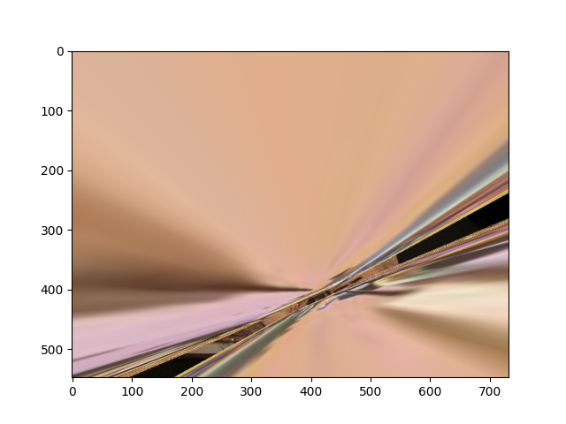

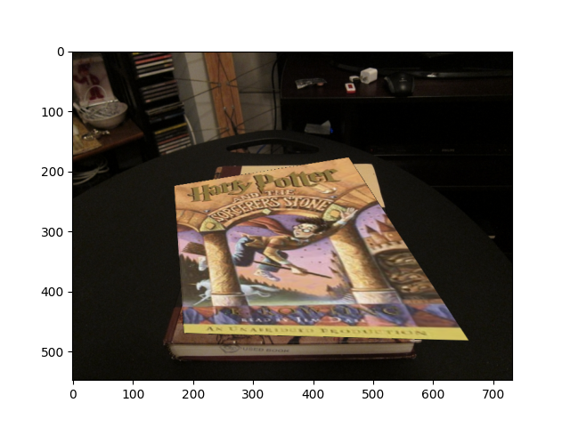 Above result: Max iteration = 10. Due to the small number of iterations, the ransac algorithm couldn’t find the accurate best2to1 matrix.

Above result: inlier tolerance = 10. By increasing inlier_tor, the ransac algorithm couldn’t find the accurate homography matrix since broad range of points were considered as inlier, leading to hinder the optimization.

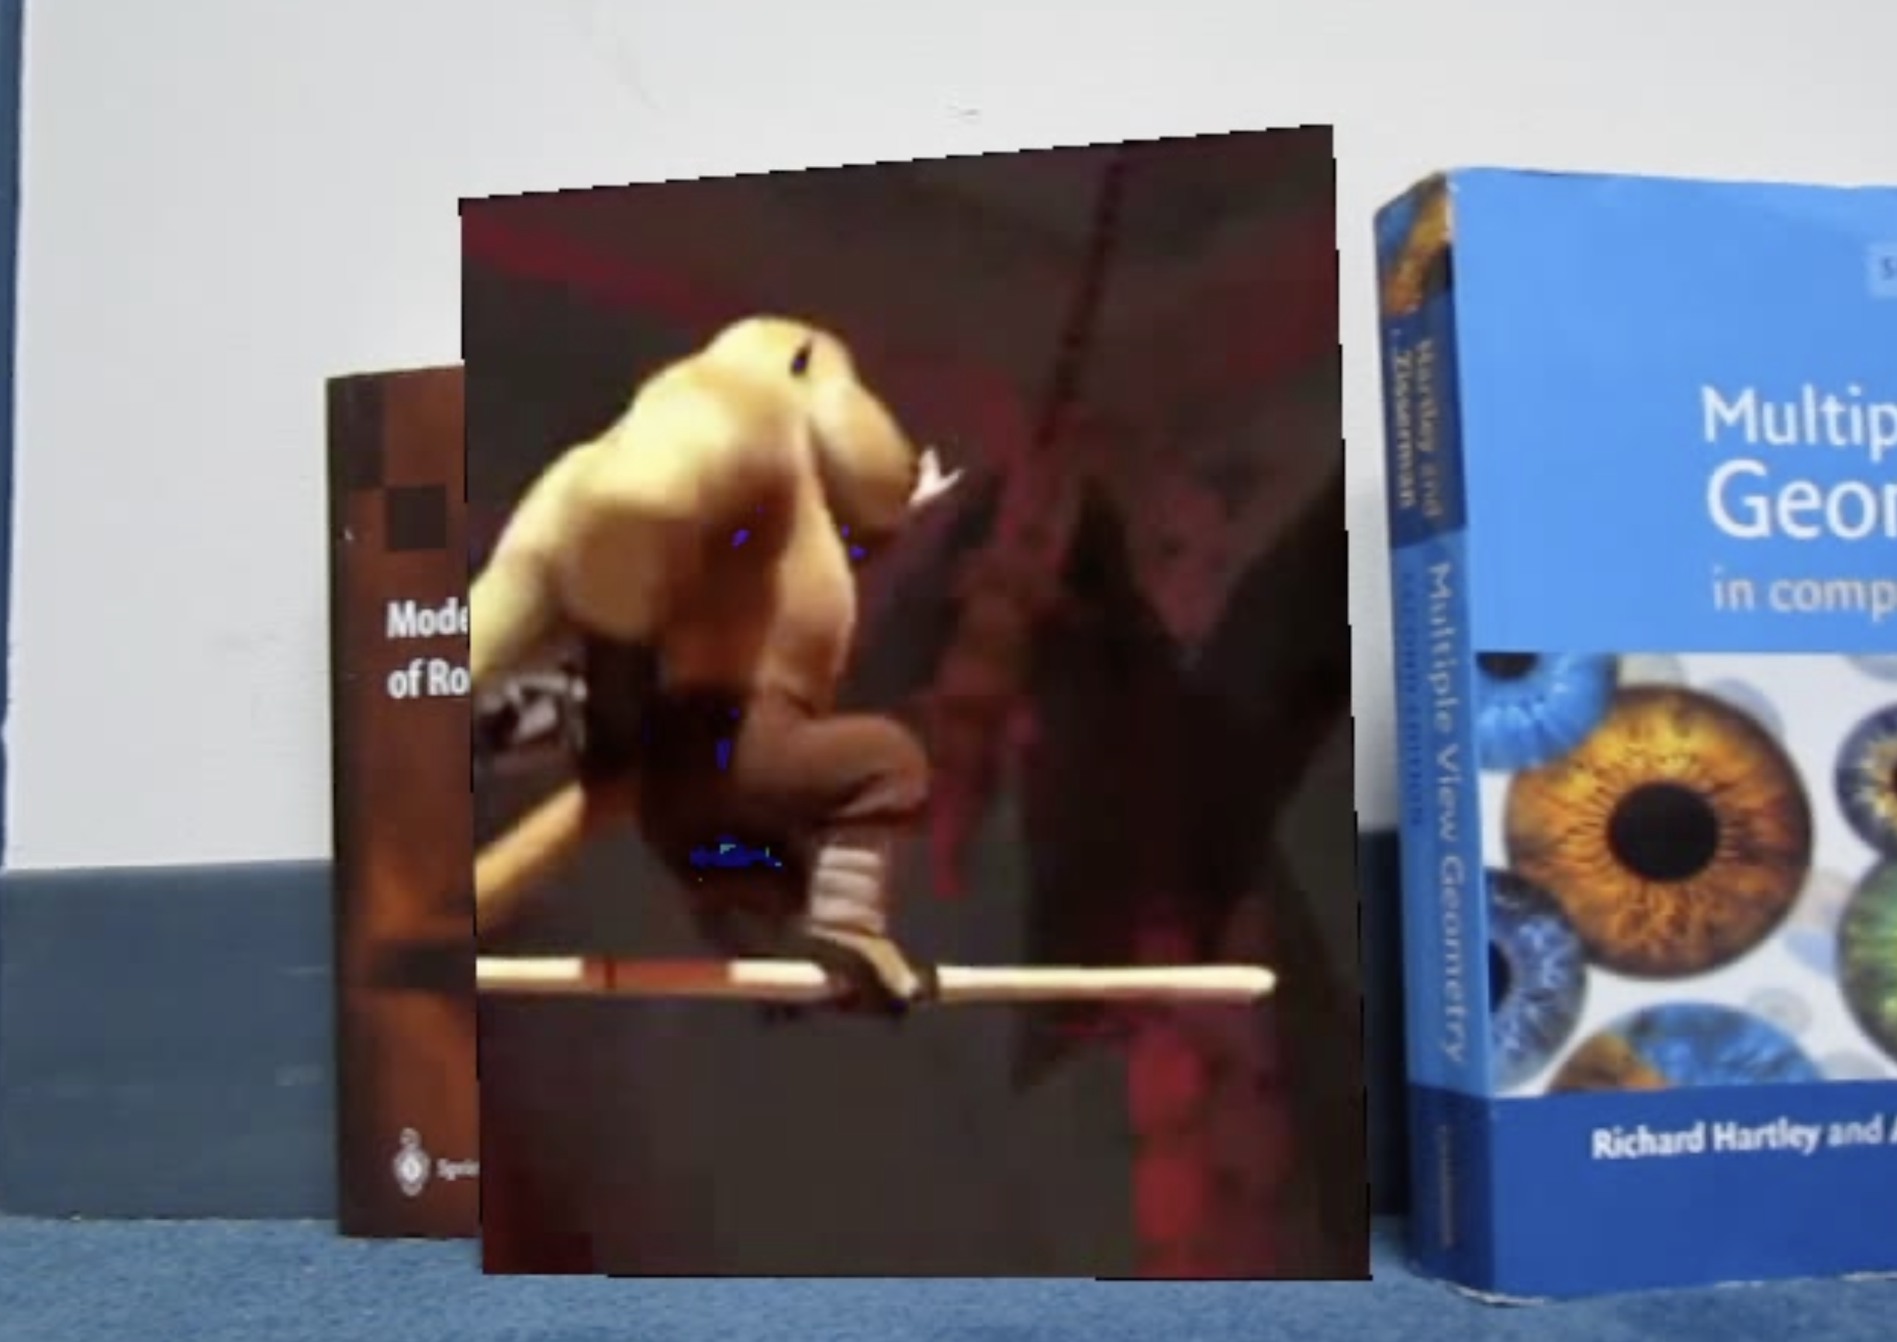

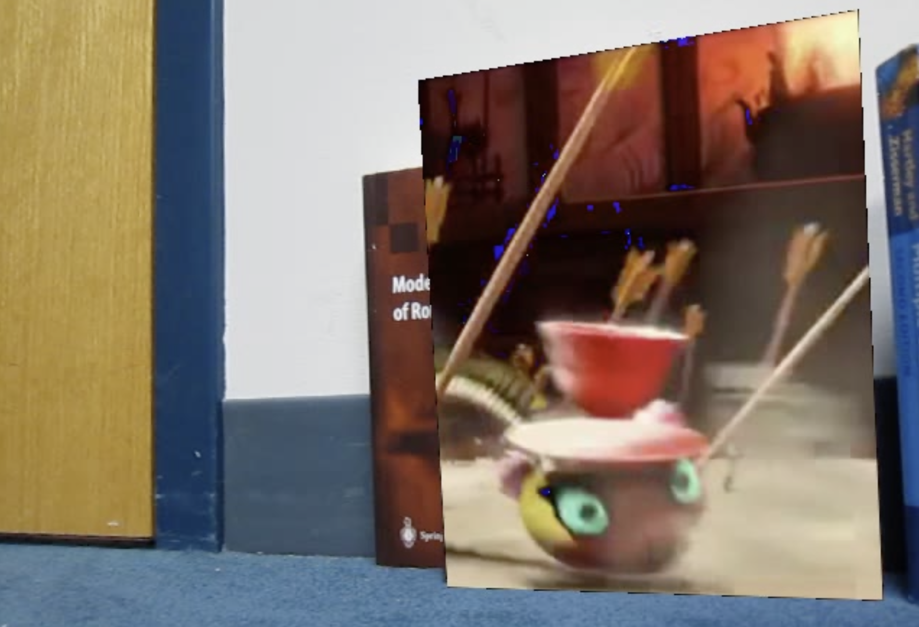

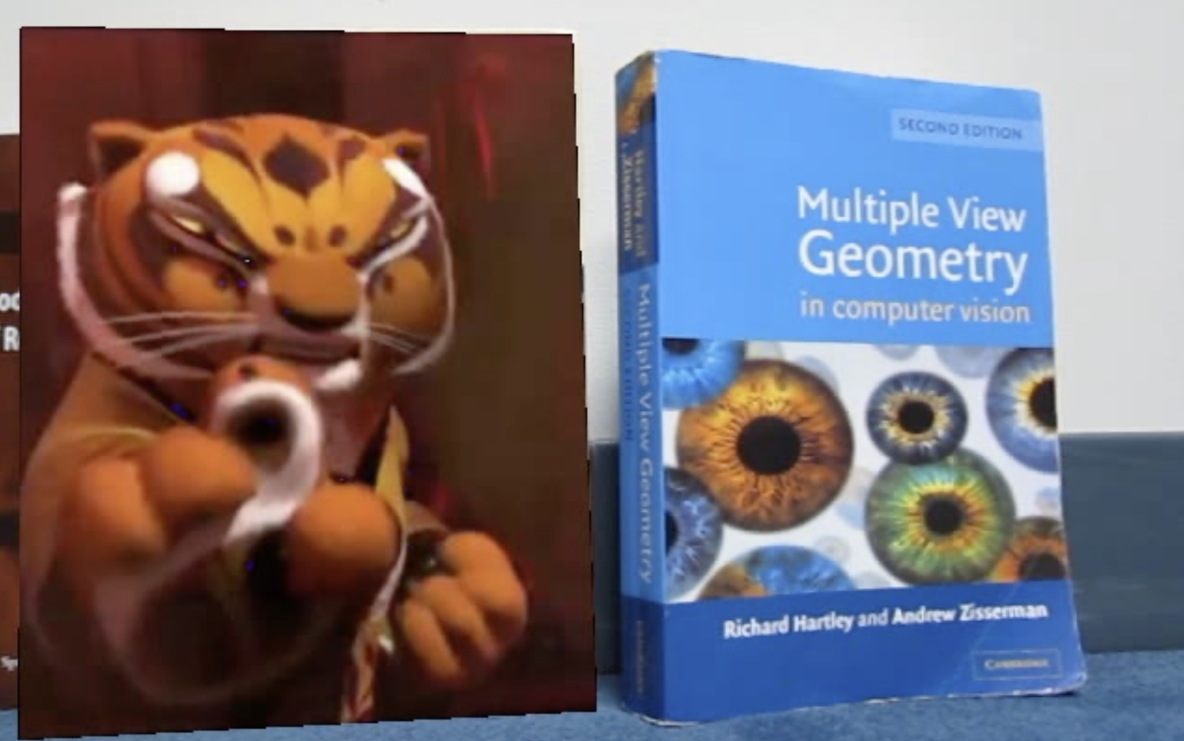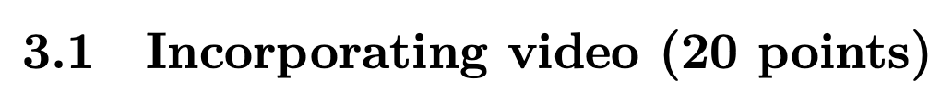d

import numpy as np

import cv2

import sys

from PIL import Image

from opts import get_opts

from tqdm import tqdm

import time

#Import necessary functions

from matchPics import matchPics

from planarH import computeH_ransac, computeH, computeH_norm, compositeH # Import necessary functions

from helper import loadVid

start = time.time()

#Write script for Q3.1

opts = get_opts()

img_cv_covoer_path = '../data/cv_cover.jpg'

img_cv_cover = Image.open(img_cv_covoer_path).convert("RGB")

img_cv_cover = np.array(img_cv_cover).astype(np.float32) / 255 #normalize

vd_book_path = "../data/book.mov"

vd_source_path = "../data/ar_source.mov"

vd_book = loadVid(vd_book_path)

vd_source = loadVid(vd_source_path)

ar_vd_list = []

# for i in tqdm(range(110, 130)):

for i in tqdm(range(len(vd_source))):

frame_book = np.array(vd_book[i]).astype(np.float32) / 255

frame_source = np.array(vd_source[i]).astype(np.float32) / 255 #normalize

# cv_cover: 440x350x3, frame_source: 360x640x3 -> crop frame to get rid of black background and have the same ratio as cv_cover

# then resize the frame

frame_source_crop = frame_source[44:314, 212:427, :]

h_cv_cover, w_cv_cover = img_cv_cover.shape[0], img_cv_cover.shape[1]

frame_source_resized = cv2.resize(frame_source_crop, (w_cv_cover, h_cv_cover))

# rotated_image = ndimage.rotate(cv_desk, 40, reshape=False)

matches, locs1, locs2 = matchPics(frame_book, img_cv_cover, opts)

locs1_matched = locs1[matches[:, 0]]

locs2_matched = locs2[matches[:, 1]]

bestH2to1, inliers = computeH_ransac(locs1_matched, locs2_matched, opts)

img_composited = compositeH(bestH2to1, frame_book, frame_source_resized)

ar_vd_list.append(img_composited)

print("time :", time.time() - start, "s")

#Saving video

ar_vd = np.stack(ar_vd_list, axis = 0)

width = ar_vd.shape[2]

hieght = ar_vd.shape[1]

channel = ar_vd.shape[3]

fps = 25.5 #similar fps to source video

fourcc = cv2.VideoWriter_fourcc(*'MJPG') # FourCC is a 4-byte code used to specify the video codec.

video = cv2.VideoWriter('ar_result_modi.avi', fourcc, float(fps), (width, hieght))

for frame_count in range(len(ar_vd)):

img = (ar_vd[frame_count]*255).astype(np.uint8)

video.write(img)

video.release()

Before modification, full video frames composition:

After modification:

I assumed the video frame changed slowly. Then, I computed the homography matrixes only for even order of the video first and performed compositing, then averaged each set of two matrixes to get the homography matrixes for odd order of the video frames.

opts = get_opts()

start = time.time()

# for i in tqdm(range(110, 130)):

img_cv_covoer_path = '../data/cv_cover.jpg'

img_cv_cover = Image.open(img_cv_covoer_path).convert("RGB")

img_cv_cover = np.array(img_cv_cover).astype(np.float32) / 255 #normalize

vd_book_path = "../data/book.mov"

vd_source_path = "../data/ar_source.mov"

vd_book = loadVid(vd_book_path)

vd_source = loadVid(vd_source_path)

H_list = []

ar_vd_even_list = []

length_vid = len(vd_source) - len(vd_source)%2 #Simply cut the last frame for even number of frames

# for i in tqdm(range(len(vd_source))):

for i in tqdm(range(int(length_vid/2))):

frame_book = np.array(vd_book[2*i]).astype(np.float32) / 255

frame_source = np.array(vd_source[2*i]).astype(np.float32) / 255 #normalize

# cv_cover: 440x350x3, frame_source: 360x640x3 -> crop frame to get rid of black background and have the same ratio as cv_cover

# then resize the frame

frame_source_crop = frame_source[44:314, 212:427, :]

h_cv_cover, w_cv_cover = img_cv_cover.shape[0], img_cv_cover.shape[1]

frame_source_resized = cv2.resize(frame_source_crop, (w_cv_cover, h_cv_cover))

# rotated_image = ndimage.rotate(cv_desk, 40, reshape=False)

matches, locs1, locs2 = matchPics(frame_book, img_cv_cover, opts)

locs1_matched = locs1[matches[:, 0]]

locs2_matched = locs2[matches[:, 1]]

bestH2to1, inliers = computeH_ransac(locs1_matched, locs2_matched, opts)

H_list.append(bestH2to1)

img_composited = compositeH(bestH2to1, frame_book, frame_source_resized)

ar_vd_even_list.append(img_composited)

ar_vd_odd_list = []

for i in range(len(H_list)-1):

frame_book = np.array(vd_book[2*i+1]).astype(np.float32) / 255

frame_source = np.array(vd_source[2*i+1]).astype(np.float32) / 255 #normalize

# cv_cover: 440x350x3, frame_source: 360x640x3 -> crop frame to get rid of black background and have the same ratio as cv_cover

# then resize the frame

frame_source_crop = frame_source[44:314, 212:427, :]

h_cv_cover, w_cv_cover = img_cv_cover.shape[0], img_cv_cover.shape[1]

frame_source_resized = cv2.resize(frame_source_crop, (w_cv_cover, h_cv_cover))

bestH2to1 = (H_list[i] + H_list[i+1])/2

img_composited = compositeH(bestH2to1, frame_book, frame_source_resized)

ar_vd_odd_list.append(img_composited)

ar_vd_list = []

for i in range(length_vid-1):

if i%2 == 0:

ar_vd_list.append(ar_vd_even_list[int(i/2)])

else:

ar_vd_list.append(ar_vd_odd_list[int((i-1)/2)])



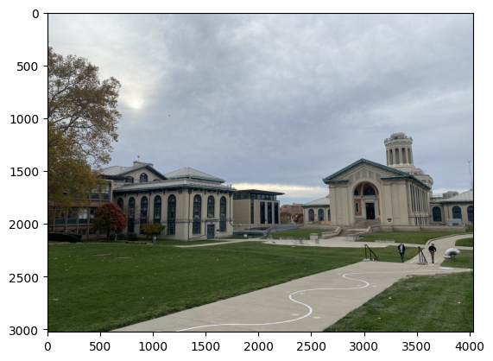

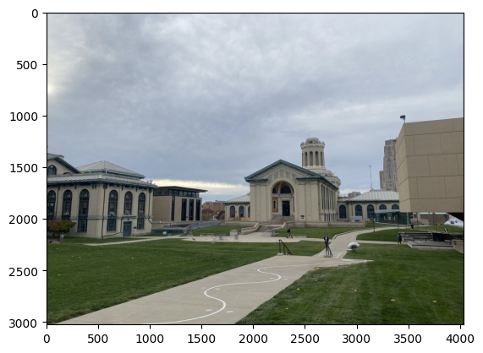

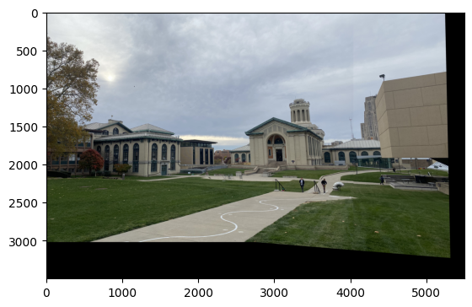

# Q4

opts = get_opts()

img_pano_left = Image.open('../data/my_pano_left.jpeg').convert("RGB")

img_pano_left = np.array(img_pano_left).astype(np.float32) / 255 #normalize

img_pano_right = Image.open('../data/my_pano_right.jpeg').convert("RGB")

img_pano_right = np.array(img_pano_right).astype(np.float32) / 255 #normalize

matches, locs1, locs2 = matchPics(img_pano_left, img_pano_right, opts)

locs1_matched = locs1[matches[:, 0]]

locs2_matched = locs2[matches[:, 1]]

bestH2to1, inliers = computeH_ransac(locs1_matched, locs2_matched, opts)

width = img_pano_left.shape[1] + img_pano_right.shape[1]

height = img_pano_left.shape[0] + img_pano_right.shape[0]

img_warped = cv2.warpPerspective(img_pano_right.swapaxes(0, 1), bestH2to1, (height, width)).swapaxes(0, 1)

img_warped[0:img_pano_left.shape[0], 0:img_pano_left.shape[1]] = img_pano_left

plt.imshow(img_warped[:1250,:2000])

plt.show()